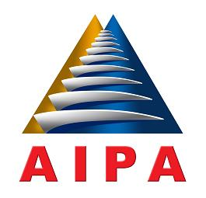

**ASEAN INTER-PARLIAMENTARY ASSEMBLY**

**33rd GENERAL ASSEMBLY**

**16 - 22 SEPTEMBER 2012, LOMBOK, INDONESIA**

**MESSAGE BY HIS MAJESTY PREAH BAT SAMDECH PREAH BOROMNEATH NORODOM SIHAMONI**

**KING OF CAMBODIA**

On this auspicious occasion, I would like to extend my affectionate greetings and express my best wishes to the 33rd General Assembly of the ASEAN Inter-Parliamentary Assembly (AIPA) presided over by His Excellency Dr. Marzuki Alie, Speaker of the House of Representatives of the Republic of Indonesia and the President of AIPA, and the High-Level Delegations of the AIPA Member Countries, and Observer Countries as well as Honored National and International Guests.

I am very pleased that this 33rd General Assembly which is being held in Lombok, Republick of Indonesia will raise the theme “Strengthening the Parliamentary Roles towards ASEAN Community 2015”.

Trough this important main theme, I hope that the close, smooth, and effective cooperation between the legislative and executive bodies will push the work to establish the ASEAN Community for the sake of our people.

I would like to express my heartfelt appreciation and sincerely hope that the discussion and exchanges of ideas over the chosen topic on the agenda from various committees will offer AIPA enormous and valuable contributions towards building the ASEAN Community together in 2015.

I wish the 33rd AIPA General Assembly success and that good and fruitful results will be accomplished for the common interest of the ASEAN Nations.